**UNIVERSIDAD DE GUADALAJARA**

**CENTRO UNIVERSITARIO DE LOS VALLES**



Administración de la configuración del software

Omar Ali Zatarain Durán

Salvador Curiel Hernández

208260648

19 de septiembre de 2023

**Index**

Contenido

Description 3

Requeriments 3

Functional requeriments 3

Non-functional requeriments 3

Key benefits 3

Requeriments Analysis 4

Project Scope 4

Definitions and Acronyms 4

Desing of system 5

# Description

This project plans to create a smart system that makes public buildings use energy more efficiently. Using modern technologies, our goal is to cut expenses, lower our impact on the environment, and encourage eco-friendly habits.

# Requeriments

## Functional requeriments

* **Ensure Energy Efficiency:** Attain a significant reduction in overall energy consumption by optimization.
* **Real-time Monitoring:** Supervise energy consumption in specific areas of the buildings.
* **Smart Automation:** Automatically control things like lights and climate based on occupancy and conditions.
* **Data Analysis:** Provide analysis to identify consumption patterns and trends.
* **Inefficiency Detection:** Detect issues like unnecessarily lit lights or faulty equipment.
* **Renewable Energy Integration:** Allow the incorporation of sustainable energy sources.
* **Additional remote server:** The client requests an additional master remote server for getting reports of usage for several buildings in different cities, it includes a module in your original project that connects to the remote server.

## Non-functional requeriments

* **Minimal Latency:** Ensure a maximum response time of 3 seconds in real-time monitoring and control.
* **Intuitive Interface:** Offer a user-friendly interface for users of varying skill levels.
* **Data Security:** Ensure the protection of consumption and control data with robust security measures.
* **Continuous Availability:** Keep your system up and running 24 hours a day.

## Key benefits

* Reduction of energy consumption and operational costs.
* Contribution to a more sustainable and eco-friendly Environment.

# Requeriments Analysis

The objective of this document is to provide a detailed description of the functional and non-functional requirements for the "Smart Energy Solution for Public Buildings" project. It serves as a fundamental resource to guide the design, development, and implementation of the energy management system.

## Project Scope

The scope of this project encompasses the creation of a comprehensive energy management system for public buildings, enabling energy consumption optimization, real-time monitoring, intelligent automation, and the integration of renewable energy sources. This system is designed to enhance energy efficiency and reduce operational costs for public buildings.

## Definitions and Acronyms

**Energy Efficiency:** The ability to use energy more efficiently to achieve the same results or services.

**Real-time Monitoring:** The capability to continuously supervise energy consumption and other resources with up-to-date information.

**Intelligent Automation:** The automation of devices and systems based on real-time data and predefined conditions.

**Renewable Energy Management:** The incorporation of sustainable and renewable energy sources, such as solar panels or wind turbines, into a building's energy system.

# Desing of system

The following diagrams showcase some of the key interactions and functions of the energy management in the project. These diagrams provide a general overview of how the system interacts with the actors to carry out essential tasks in energy management.

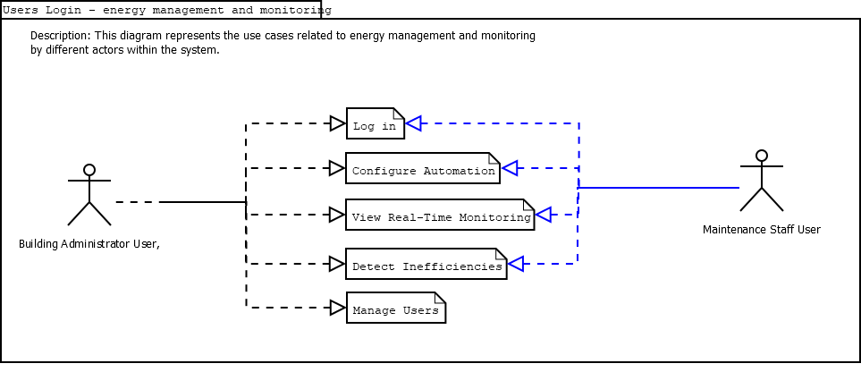

Image 1 - Energy and monitoring use case diagram.

**Use Cases:**

* **Log In:** Allows users to log in to the system.
* **Configure Automation:** Allows the administrator user to configure lighting and climate automation.
* **View Real-Time Monitoring:** Allows users to view real-time monitoring of energy consumption.
* **Detect Inefficiencies:** Allows users to report and manage energy inefficiencies.
* **Generate Reports:** Allows users to generate energy consumption reports.
* **Manage Users:** Allows the administrator user to manage user accounts and permissions.

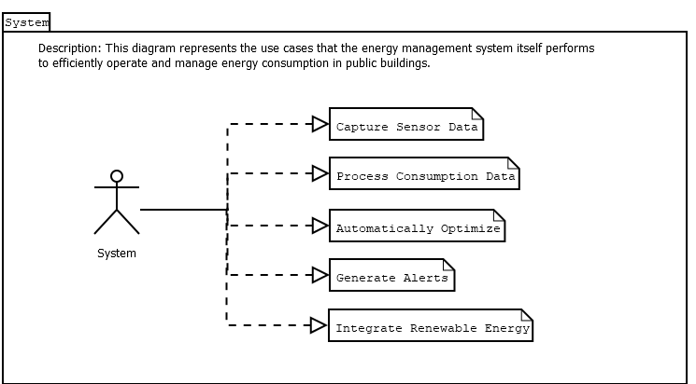

Image 2 - System use case diagram.

**Use Cases:**

* **Capture Sensor Data:** Allows the system to capture data from energy consumption sensors.
* **Process Consumption Data:** The system processes consumption data for analysis.
* **Automatically Optimize:** The system makes automatic adjustments based on data and optimization algorithms.
* **Generate Alerts:** The system generates alerts in case of inefficiencies or abnormal situations.
* **Integrate Renewable Energy:** Allows the system to integrate energy from renewable sources when available.